**Module-6: Database Services Assignment – 3**

1. **Created a Database table and given partition key as ID**

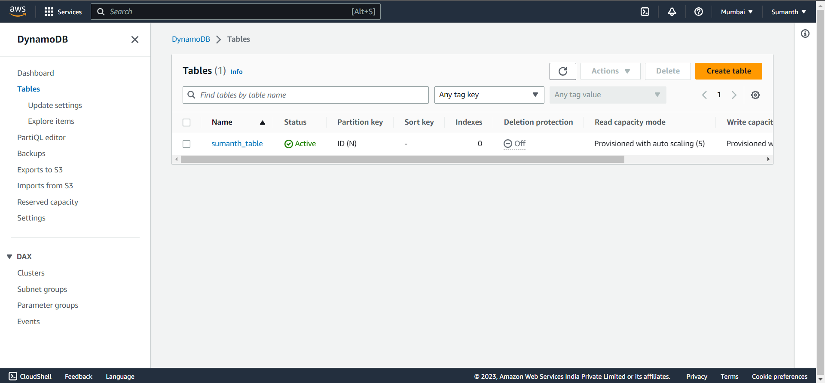

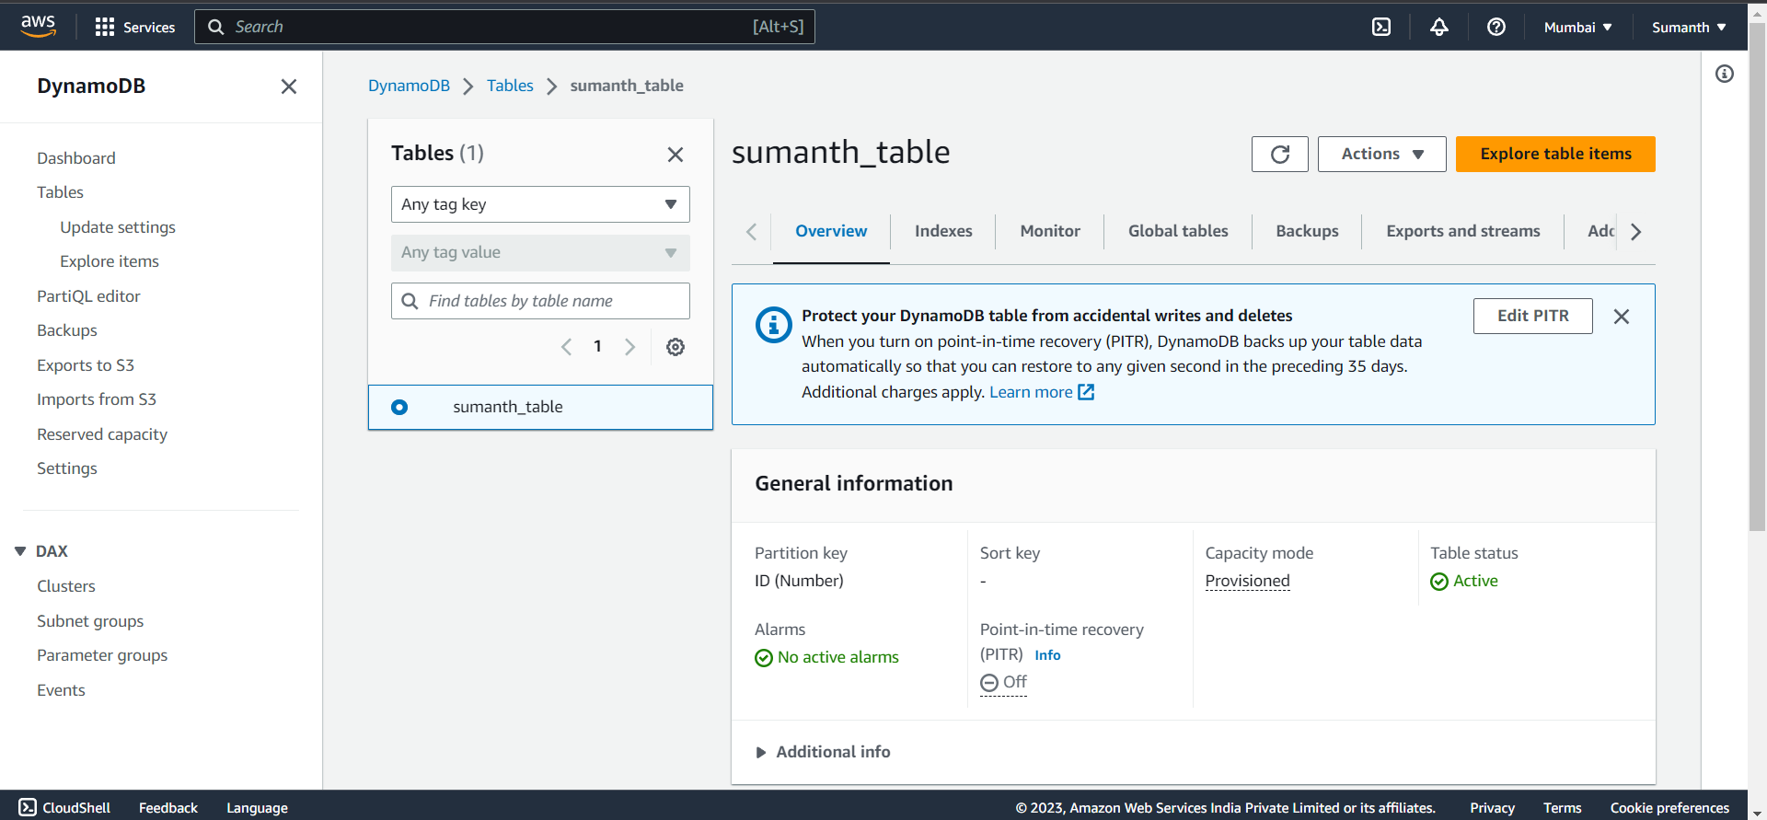

1. **Added 3 items to the Dynamo DB table**

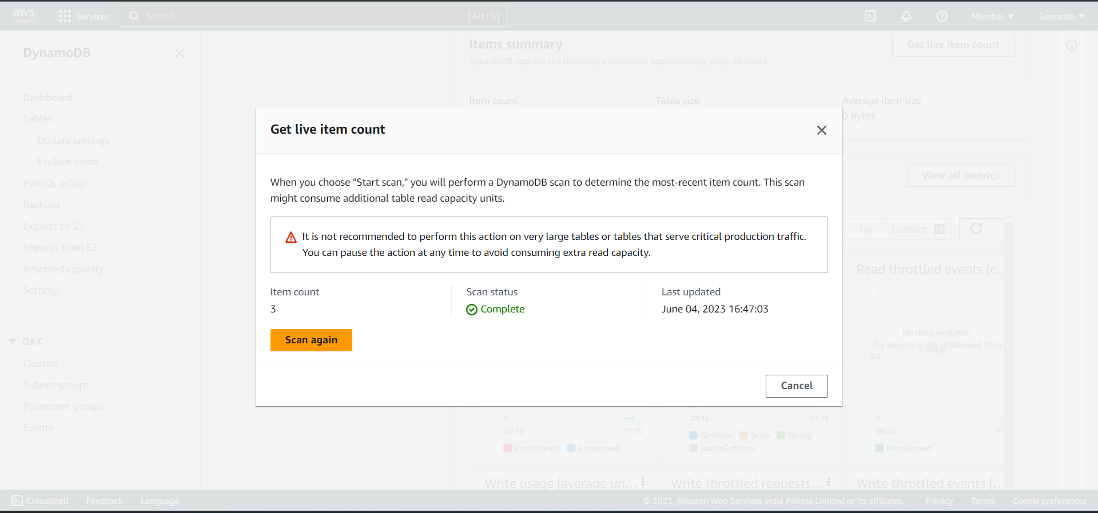

1. **Created a backup for the table**

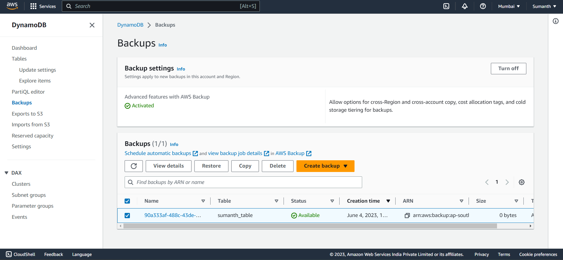

1. **Deleted the Table**
2. **Requested for restoration of the table**

